Object-Oriented Database

An object-oriented database (OODBMS) or object database management system (ODBMS) is a database that is based on object-oriented programming (OOP). In OOP, an entity is represented as an object and objects are stored in memory. The objects have members such as fields, properties, and methods. They also have a life cycle that includes the creation of an object, use of an object, and deletion of an object. One thing to keep in mind is OOP has key characteristics, encapsulation, inheritance, and polymorphism.

Advantages of Object Databases:

One of the main advantages of OODBMS is that it provides persistent storage to objects. Imagine creating objects in your program and saving them as it is in a database and reading back from the database. Hence faster data access and better performance.

Drawbacks of Object Databases:

As with all technology there is the good and the bad.

* Object databases are not as popular as RDBMS. It is difficult to find object DB developers.
* Not many programming language support object databases.
* RDBMS have SQL as a standard query language. Object databases do not have a standard.
* Object databases are difficult to learn for non-programmers.

The key comparisons can be seen in the table below.

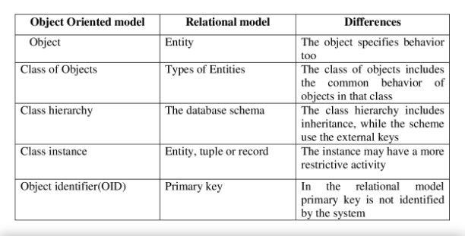

Fig1 ©Rutija S Ghongade and P.J Pursani

Example of an Object-Orientated Database:

Complex objects are built by applying constructors to simpler objects including: sets, lists and tuples.

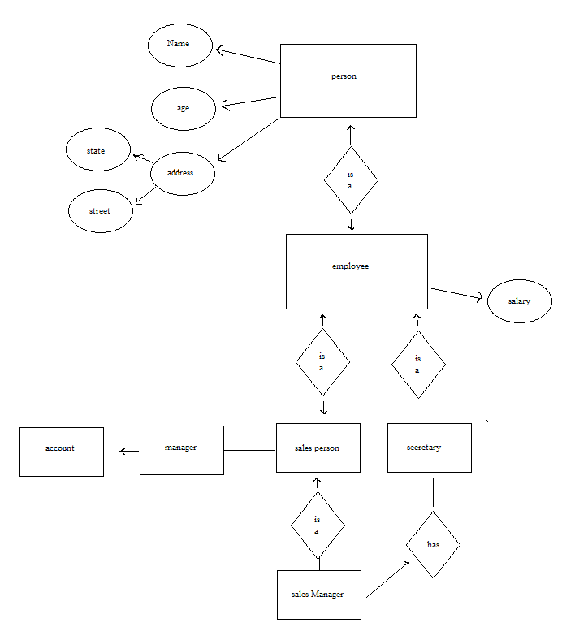

EXAMPLE 1:  
Employee is a subtype of Person  
SalesPerson is a subtype of Employee  
Addresses have street names  
Salespeople have sales managers  
sales managers have secretaries  
secretaries are employees

Object SQL Query: retrieve the name and state of all people who are older than 21:

Select Name(p), State(Address(p)

for each Person p

where Age(p) > 21

EXAMPLE 2:

Retrieve the street name of the address of the secretary of the manager of each salesperson whose salary is more than 50,000:

Select

StreetName(Address(Secretary(Manager(0))))

for each SalesPerson p

where Salary(p) > $50,000

References:

Dietrich Suzanne W. and Urban Susan D.(2011) Fundamentals of Object Databases Object-Oriented and Object-Relational Design: Morgan & Claypool Publishers.